Contents…………………………………………………………………………………………………………………1
Introduction………………………………………………………………………………………………………………….2
Project Organization………………………………………………………………………………………………………..2
Risk Analysis………………………………………………………………………………………………………………3-4
Hardware Requirements……………………………………………………………………………………………………5
Software Requirements……………………………………………………………………………………………………..5
Work Breakdown……………………………………………………………………………………………………………..6
UML Diagram…………………………………………………………………………………………………………………7
Project Schedule………………………………………………………………………………………………………..…8-9
Monitoring and Reporting Mechanisms………………………………………………………………………………10-13
Objectives Completed…………………………………………………………………………………………………..14
Appendix…………………………………………………………………………………………………………………15 - 17

Introduction:
This Project will be an entertaining 2D rouge like card game that will test the users critical thinking and planning. This project will offer a unique spin to similar games such as Balatro and Solitarica. This game will be made with the sole purpose of enriching our users with a simple but satisfying experience, the project will be accessible to multiple systems, allowing many to experience it. The game will have the user overcome challenging enemies using poker rules, as the user progresses the user will be given options to upgrade their loadout as difficulty increases. This game will favor those who are able to conserve their resources and plan 2 steps ahead. This game will be a stepping stone to inspire users into trying other experiences such as the very ones that inspired the project.

Project Organization:
Position | Name | Description
Organizer | Kyle Nguyen | Ensures that the project meetings occur and that the project is being worked on efficiently and securely. Also creates the assets and art design for the game. May also assist in coding, UI layout, and design.
Designer
Programmer | Laketon Pfeiffer | Writes the code for the program and tests the program for any errors. Will be working on scripting the game and designing the layout of the game as well as the logic behind the game.
Tester

Less members require a heavier work load.
Risk Analysis
Risk | Probability | Effect | Planning
Late Programming Finalization/Late Delivery | High: There may not be enough time to bugtest and fix everything | Large: Team will have to submit with what bugs remain | To minimize the effects of scheduling issues or late deliveries, Team 1 will plan out a good schedule and ensure members understand and adhere to it. The project will be compared against the plan to know when to do extra work.
Unfinished Art | High: Art may be unsatisfactory if programming demands more attention | Medium: Project can be submitted with unsatisfactory art, but will likely lose points | The team can source some extra art from friends, or through commission if necessary.
Team members unavailable | Moderate: Bad weather could cause power outages | Large: Team will have to dedicate extra time to make up for missing work | Sharing contact information and keeping in touch with members through use of ivylearn inbox and/or discord. Usage of ivy tech services in the extreme scenario.
Local Hardware Failure | Moderate: It is possible that a workstation breaks during the next 12 weeks | Large: Team member will have to find an alternate way to continue work | The team will find alternative ways to work, such as backup computers. Alternatively, purchasing new equipment.
Cloud Software Failure | Moderate: Cloudflare and other providers have been dealing with DDOS attacks more frequently | Medium: Any non local files will be lost | The team can keep extra copies of the project locally in the event that the cloud software loses the project data.
Software Incompatible | Low: Unity can handle many different game types, even if not optimized for most of them | Large: Team will have to redo all programming work | The team will monitor the progress closely. If the project doesn’t look feasible on Unity, the team will switch as soon as possible to reduce wasted time.
Budget Risk | Low: Project doesn’t use much money, so is unlikely to run out of budget | Large: Team will be unable to purchase any material for the project. | Free to use applications and resources, and volunteer assistance from friends. The project is designed and planned using free resources, if expense does occur teammates agree to split the bill evenly.
Misaligned schedules | Low: A team of two is unlikely to have scheduling conflicts | Small: Team can meet on other days of the week | The team will schedule additional meetings as needed. Contact information has been shared to allow for communication between teammates, emergency meetings can be assigned.
Graphical failure | Low: Unity runs well on many machines and OS types, making graphical failure unlikely | Small: Team will have to bugfix or optimize rendering | The team will playtest on a variety of machines during development to ensure it works on different platforms. Extra time will be allocated to the graphics if error does occur.

Hardware requirements
Viable Desktop Computers:
- Linux
- MacOS
- Windows
Physical requirements:
- Monitor
- Mouse and Keyboard
Graphics requirements (minimum):
- Intel UHD / Iris Xe
- AMD Radeon Vega integrated graphics
- Any modern graphics card is more than enough
Software requirements
Operation System:
- Windows (7+)
- MacOS (Intel)
- Linux
Game Engine:
- Unity / C#
Export / Game storage:
- Github
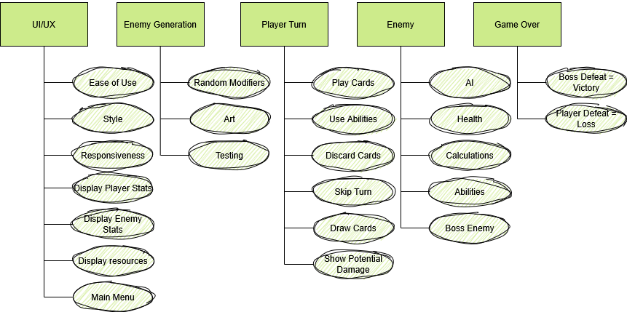
Work Breakdown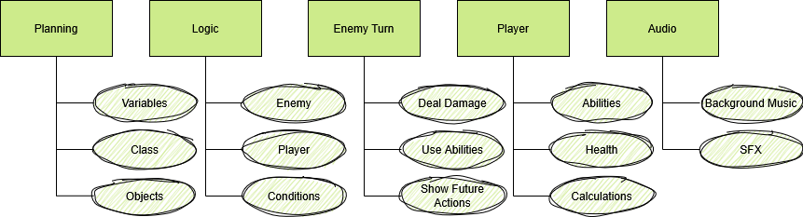UML Diagram of Object Classes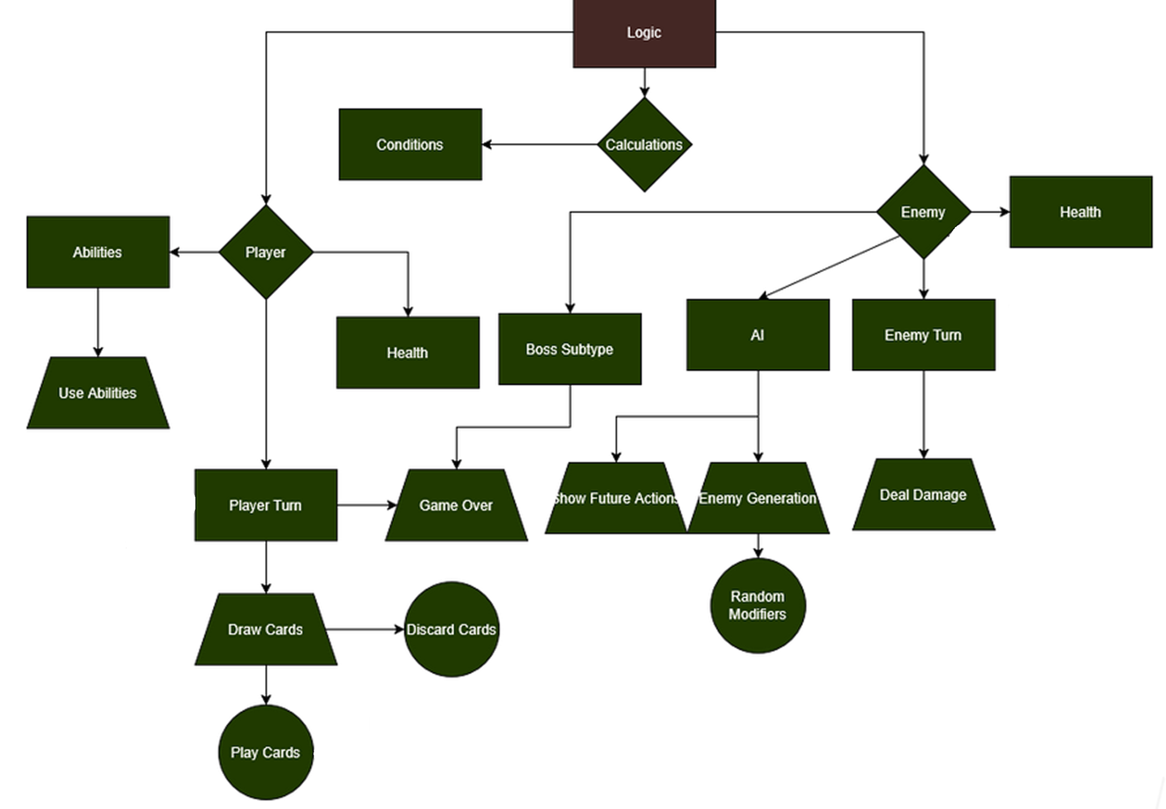

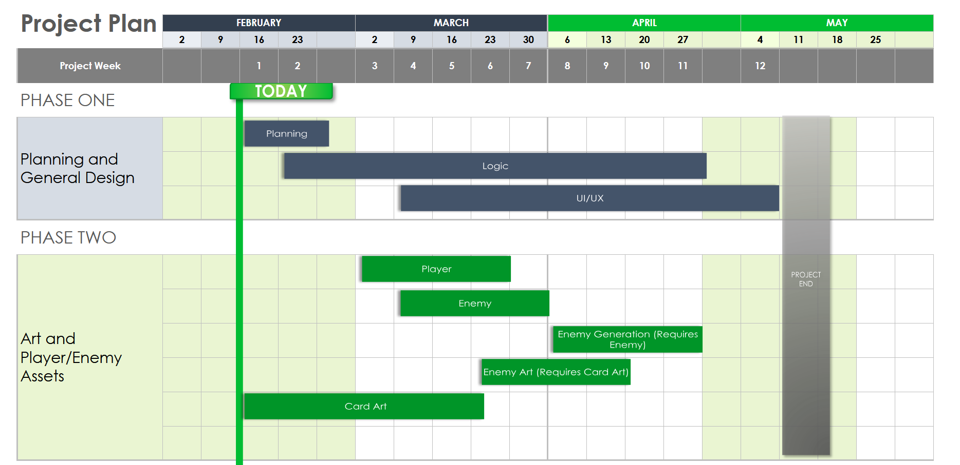
Project Schedule
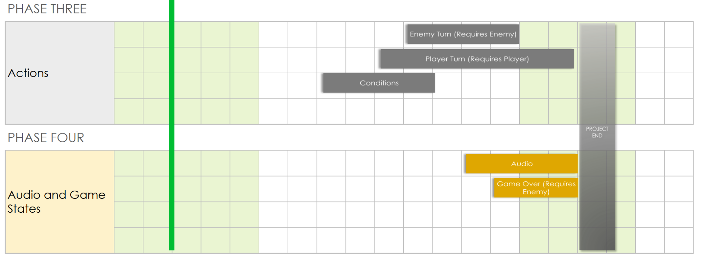
Project Schedule
Phase 1 and 2 will be worked on first and monitored closely to ensure workload follows the schedule. Extra Time will be allocated should one task require more time, especially those that are requirements for other tasks. Week 8 is the busiest week, as there are many tasks overlapped in that week, so special attention will be placed on it to adhere to the schedule.

Monitoring and Reporting Mechanisms

- Discord
  - Main Form of communication
    - Contact members
    - Schedule meetings
    - Discuss Project Progress
  - Team Meetings
    - Meet through call
    - Discuss and work on program
  - Small File Sharing
    - Images
    - Links
    - Embedded Files
  - Screen Sharing
    - Check on one another in meetings
    - Peer review
    - Objective sharing (Visually)


Monitoring and Reporting Mechanisms
- OBS
  - Records meetings
  - Audio/SFX recording


- Github
  - Program Synchronization
  - Cloud Storage
  - Version Control
  - Releases


- Unity
  - Synchronized game development
    - Class creation



- Google Drive
  - Shared Filing
    - Google Docs
    - Google Sheets
- Trello

  - Compare progress to plan
  - Assign Tasks

Objectives Completed
Back end objectives:
- Card, Pokerhand (Date: March 16th, 2026) Laketon Pfeiffer
- Hand Evaluation, player hand, enemy, player, battle manager, and damager calculator (March 24th, 2026) Laketon Pfeiffer
- Turn manager, player (April 7th, 2026) Laketon Pfeiffer
- Game Scene UI implementation + functions (April 24th, 2026) Laketon Pfeiffer
- Abilities (May 2nd, 2026) Laketon Pfeiffer
- Potions, decision scene, and gameover scene, Demo Release (May 3rd, 2026) Laketon Pfeiffer
- Bug fixes (When they occurred in code) Laketon Pfeiffer + Kyle Nguyen
UI implementations:
- Main Menu initialized + asset imports (March 24th) Kyle Nguyen
- Settings(April 7th, 2026) Kyle Nguyen
Art:
- UI art (March 24th) Kyle Nguyen
- Card art, card back art, background art (April 14th, 2026) Kyle Nguyen
- Enemy + boss sprites (april 26th, 2026) Kyle Nguyen
- Animation rigging completion (May 7th, 2026) Kyle Nguyen
Front end objectives:
- Music + Sounds (may 7th) Kyle Nguyen
- Scenes Finalization (May 10th, 2026) Laketon Pfeiffer + Kyle Nguyen
- Boss + Enemy spawns (May 7th, 2026) Laketon Pfeiffer + Kyle Nguyen
- Final statistics (May 10th, 2026) Laketon Pfeiffer + Kyle Nguyen
- Help, Gameplay, and settings Functions (May 9th, 2026) Kyle Nguyen
FInal Game Configurations / tweaks (May 10th, 2026) Laketon Pfeiffer + Kyle Nguyen
Appendix

Activity | Description | Estimated Time | Dependencies
Planning | Executable plan for the project members. Creation and implementation of work schedule and handling. Guidelines for project members. | 5 Hours | Download the latest software required for the project. Use of discord for communication. Use of documentation software.
Logic | How the game will run and operate, includes enemies, cards, abilities, victory conditions, UI, and player actions. (Everything below is an extension of the game logic asides from artwork, Listed in red) | 40 Hours | Unity 2D
Player | Players can choose abilities, players will be assigned with game rules such as health and calculations for damage. The Player is the game loop. | 8 Hours | Unity 2D
Enemy | Enemy AI and actions, base health (No modifiers till Enemy Gen), Enemy ability or type, Boss Enemy. Enemy will be what the player will go up against as they progress. | 8 Hours | Unity 2D, Player
Enemy Modifier | Special modifier given to Boss type enemies, calculated before player turn. Also determines enemy speed and difficulty, adds randomization to the enemy. | 4 Hours | Unity 2D, Player, Enemy, Enemy Modifier
Player Turn | Player turn will check for playable hand for player, calculate damage against current enemy (Modifiers are added on this stage). Enemies can start doing damage to players. Allow the player to make an action such as discarding and skipping for nuance. | 14 Hour | Unity 2D, Player, Enemy, Enemy Modifier
Game Over | Activates once a player loses all health or defeats the final boss. Then resets the player back to square one with possible skill points to unlock abilities. | 6 Hours | Unity 2D, Player Turn, Player
UI/UX | Clickable and interactable, Menu, Sliders, Health Displays, Enemy stats, Ability displays, Game Over display, victory display, buttons. | 6 Hours | Unity 2D, Uses all game dependencies
Audio | Game Sound Effects and Music | 4 Hours | Unity 2D,interacts with all dependencies
Art Work | For UI/UX, Game Sprites, Simple animation | 12 Hours | Unity 2D, interacts with all dependencies

